* CB FSD - Integration and Deployment

Day 10 : 25 July 2024

EC2 instance : AWS elastic cloud compute.

EC2 instance help us to create virtual server machine. While creating machine we can configure os(window or non window) with RAM and external memory. Then we can installed requires software depending upon requirement like java, node, python, etc and run those application in EC2 instance. EC2 instance provide us public as well private ip address which help to access the application.

S3 bucket to share spring boot jar file and using wget command we can download uploaded jar file in EC2 instance.

If we want download resources from bucket we need to install AWS cli command in local machine or ec2 instance. Using S3 URI we can download resources part of bucket.

Deploy spring boot jar file on EC2 instance using S3 bucket.

Please upload spring boot jar file in S3 bucket

Now we need to create EC2 instance

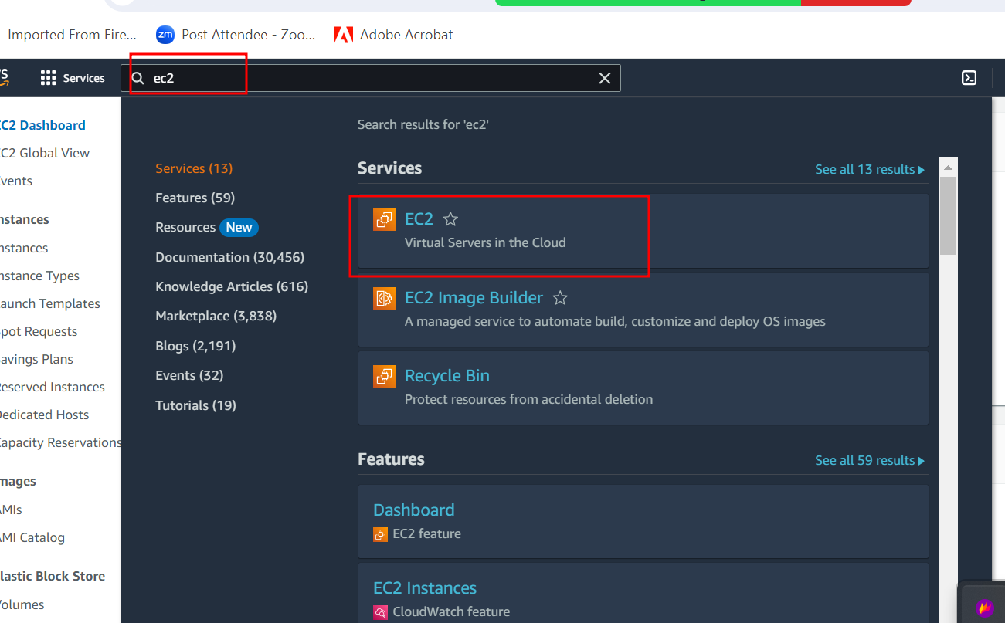

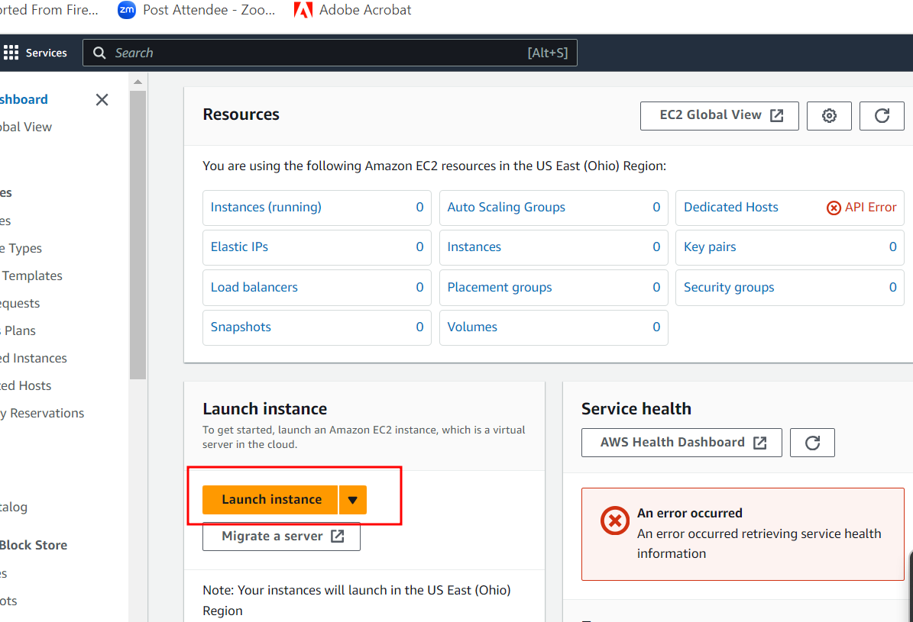

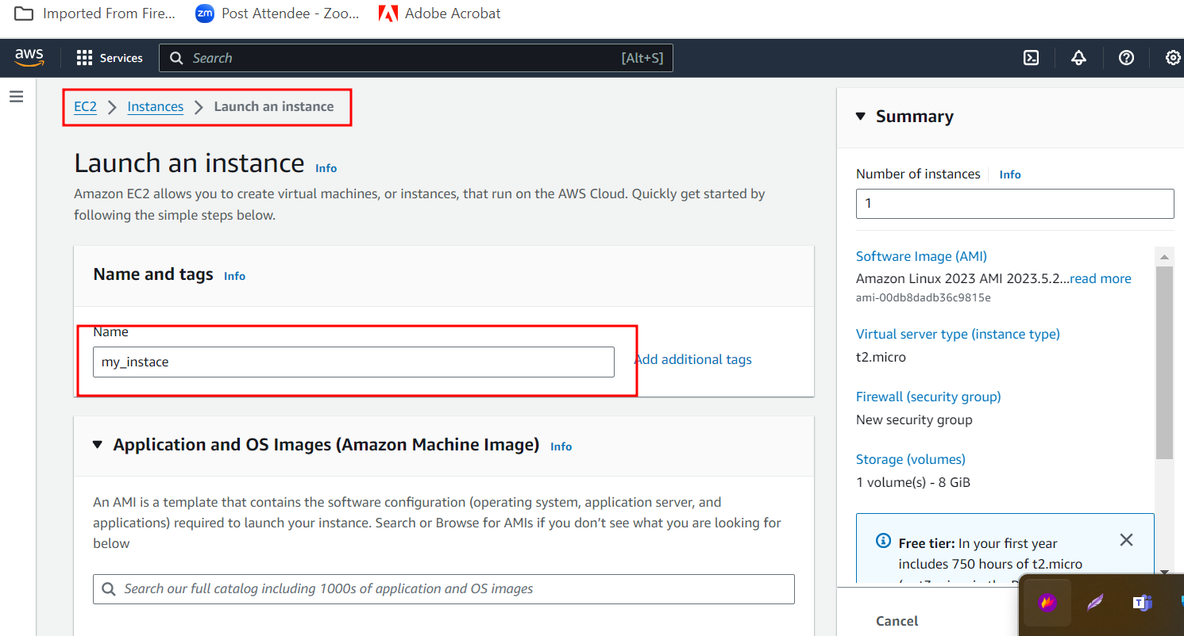

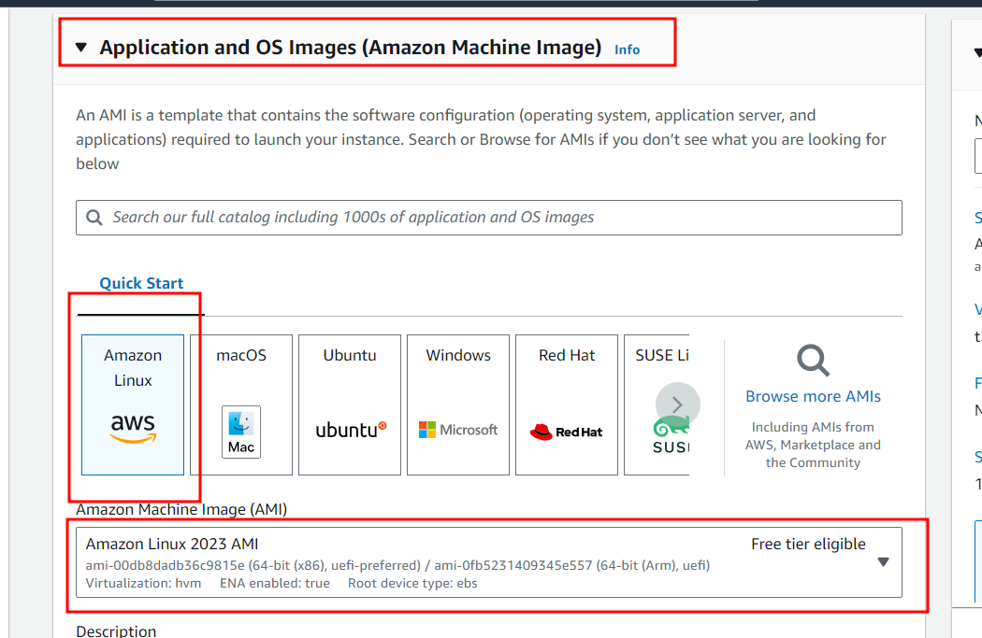

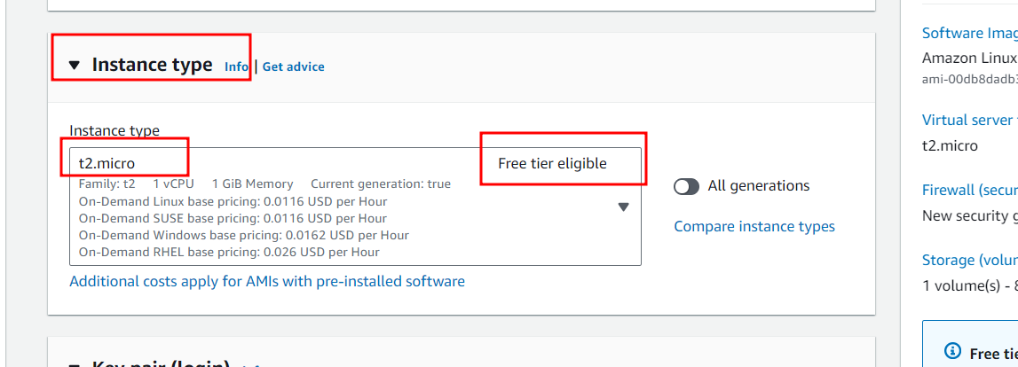

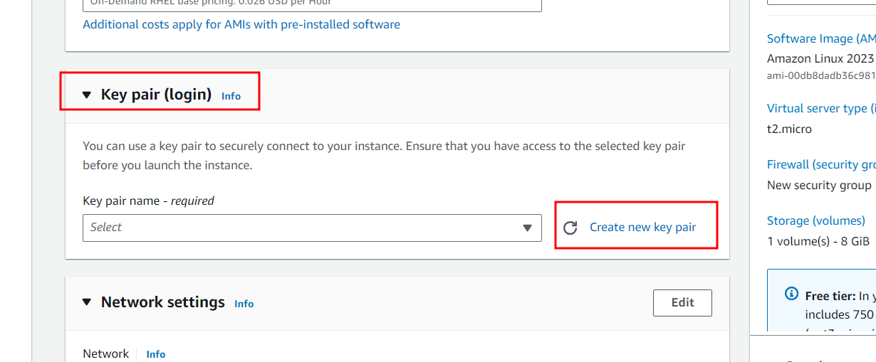

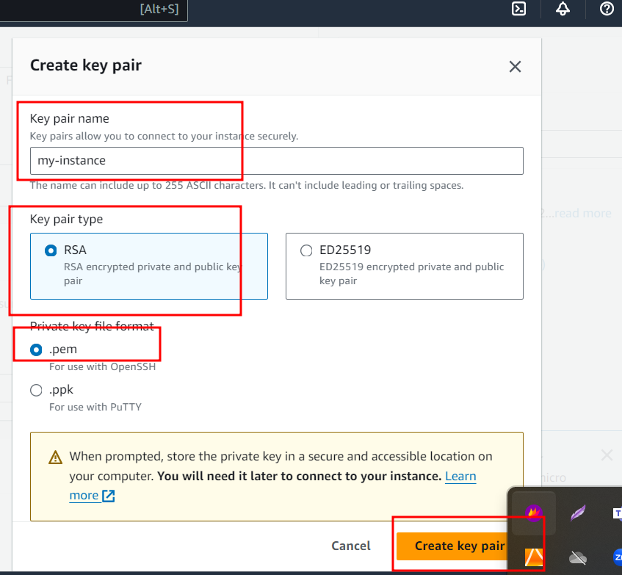

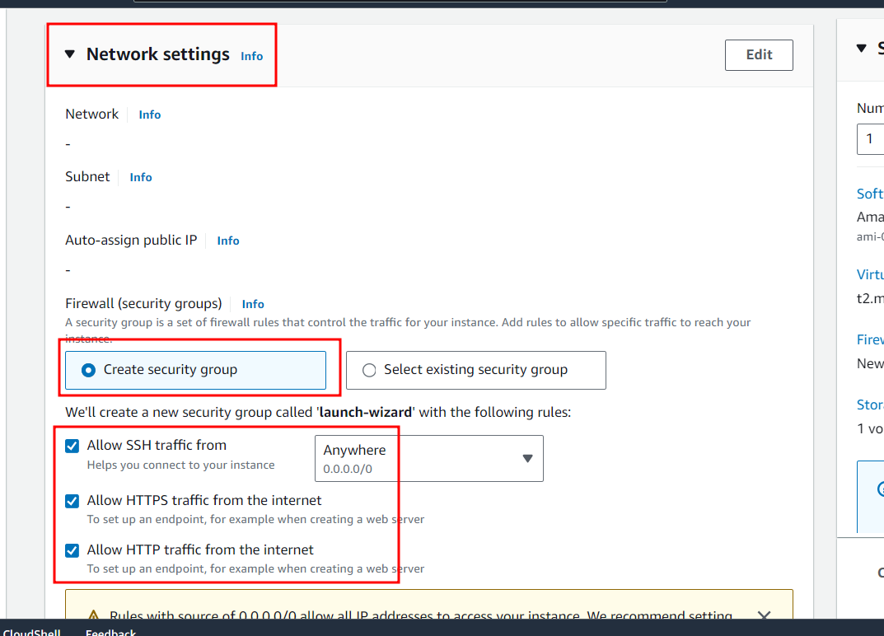

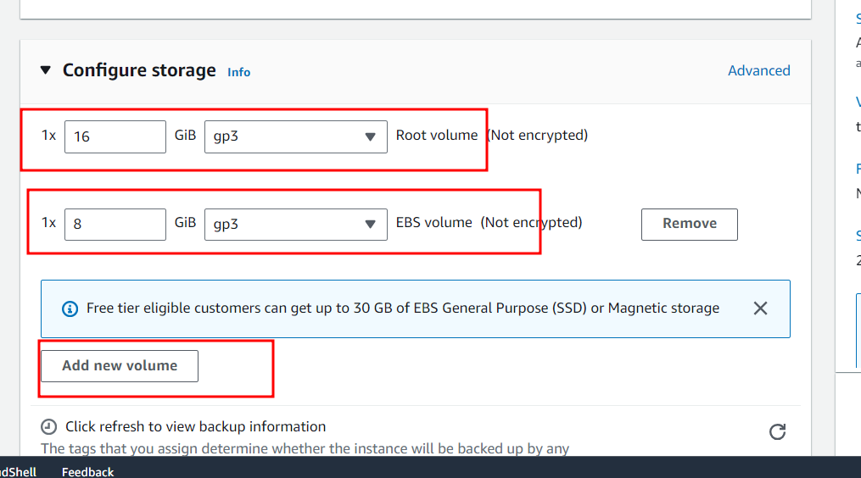

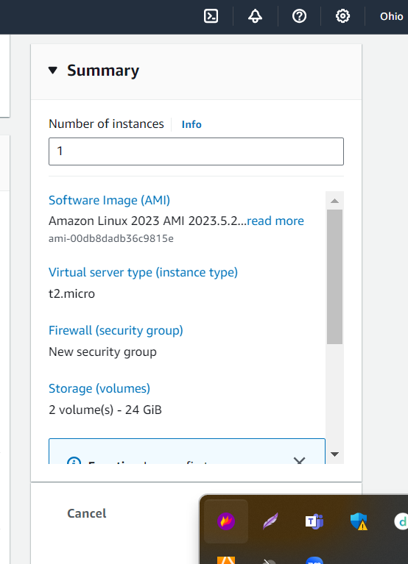



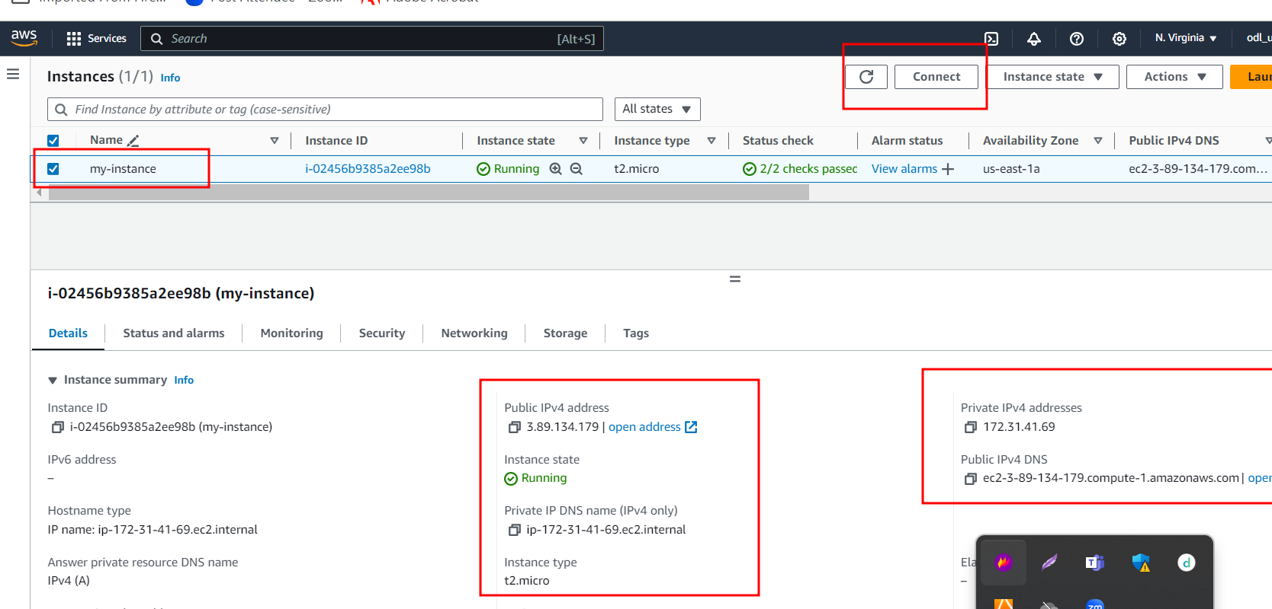

Now we are connecting EC2 instance using SSH client terminal

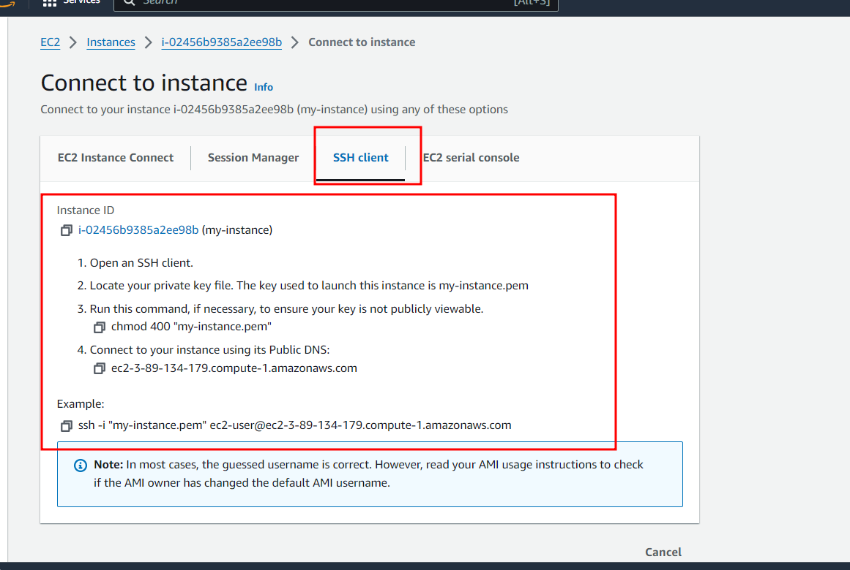

Open gitbash(window) or terminal (form non window user) in the location .pem file present

Then run command

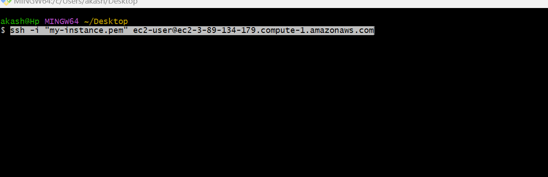

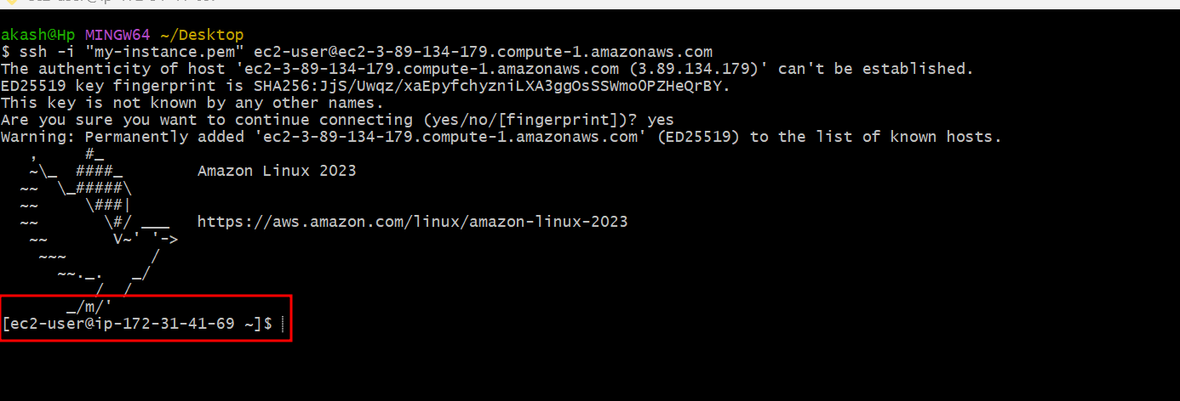

After connected successfully we can download spring boot jar file from S3 bucket

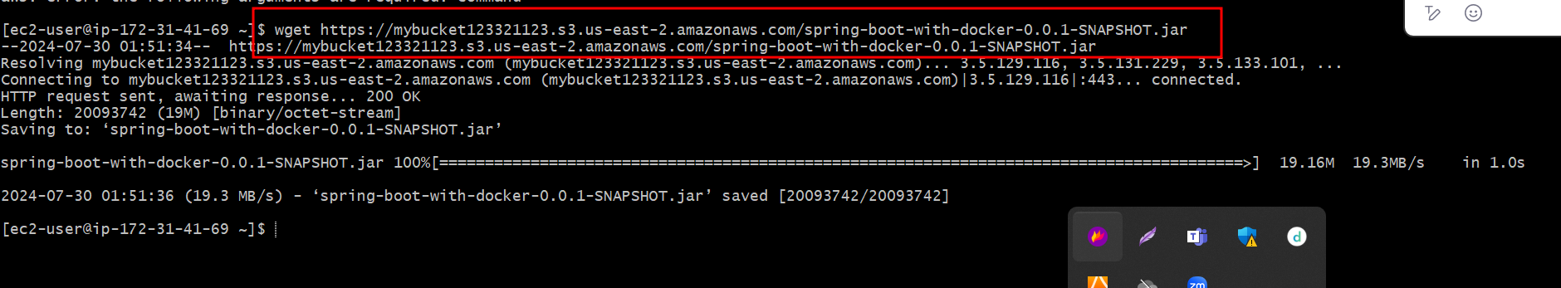

Now we need to install java software

sudo yum install java-17

java -version

java -jar filename.jar

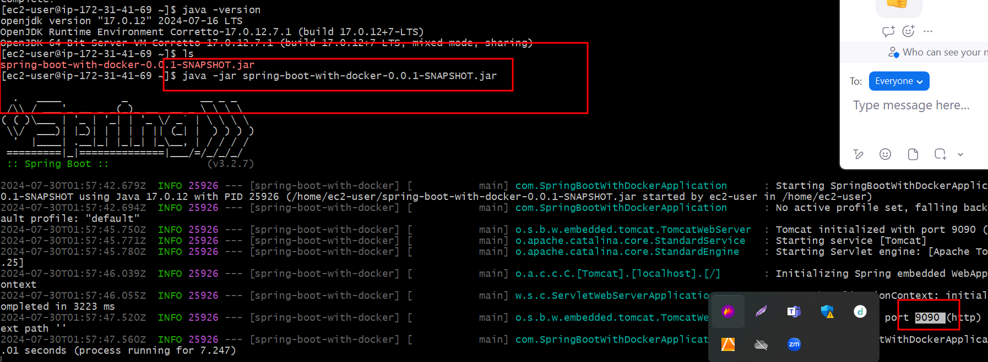

Now try to access your application using public ipaddress:portnumber

<http://publicipaddress:portnumber>

Now we need to open the port number.

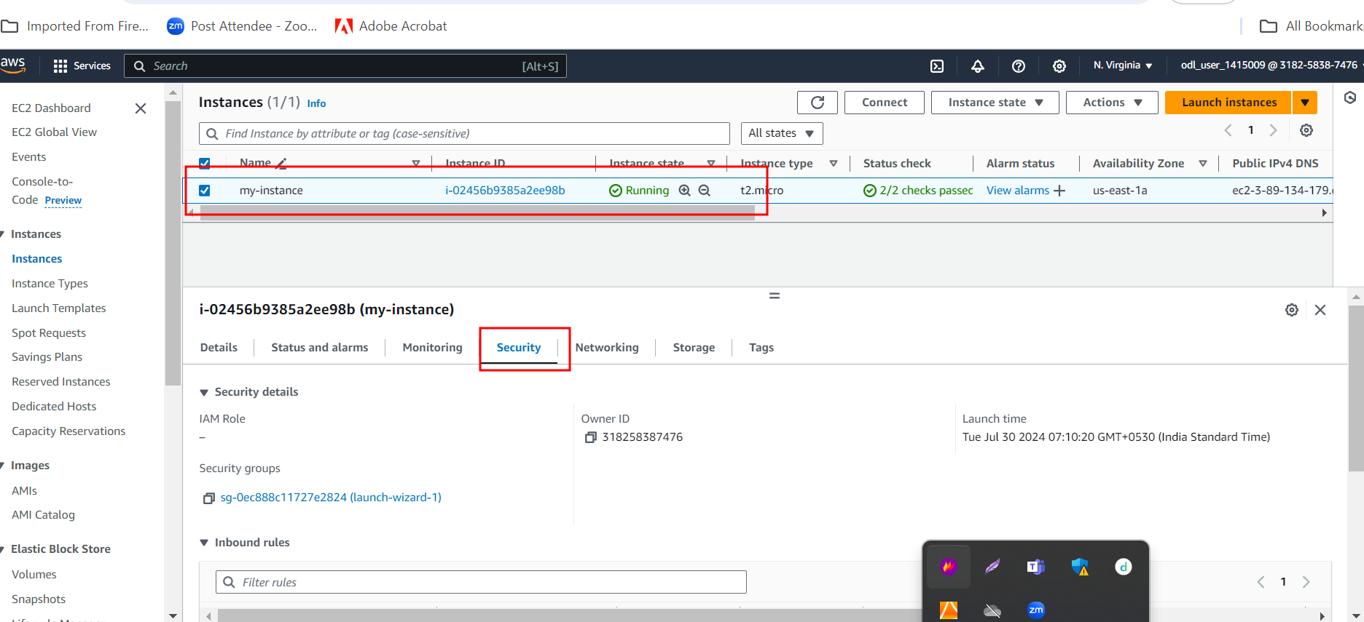

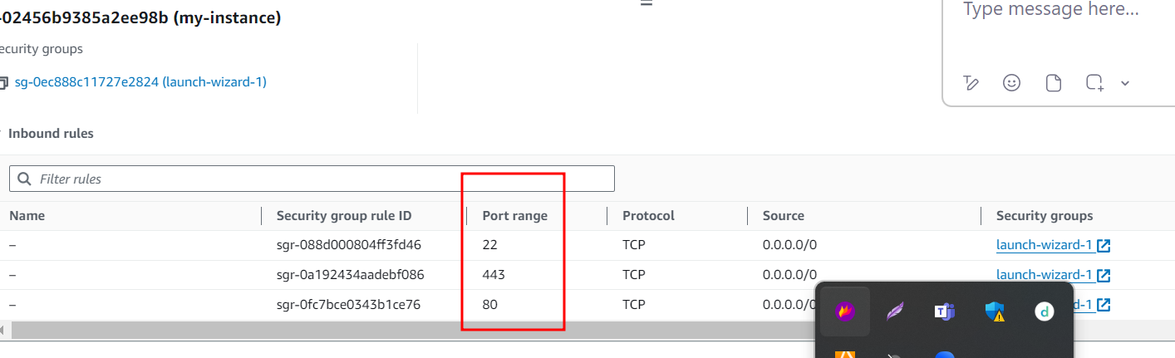

Please click on launch-wizard

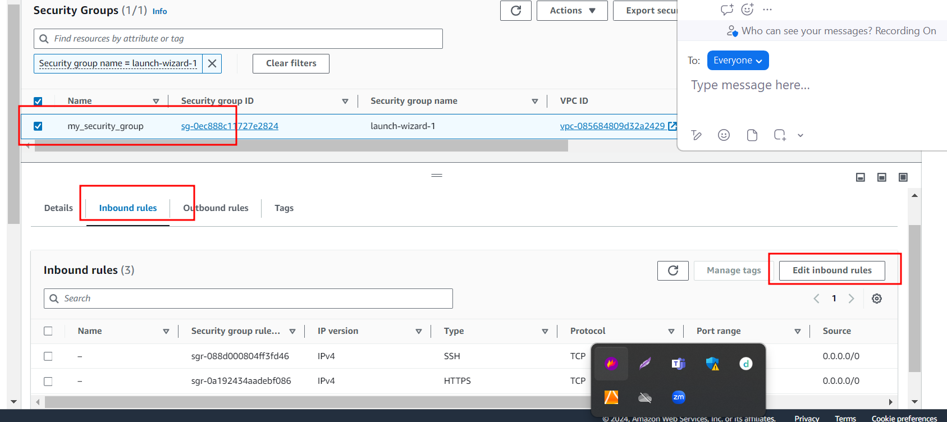

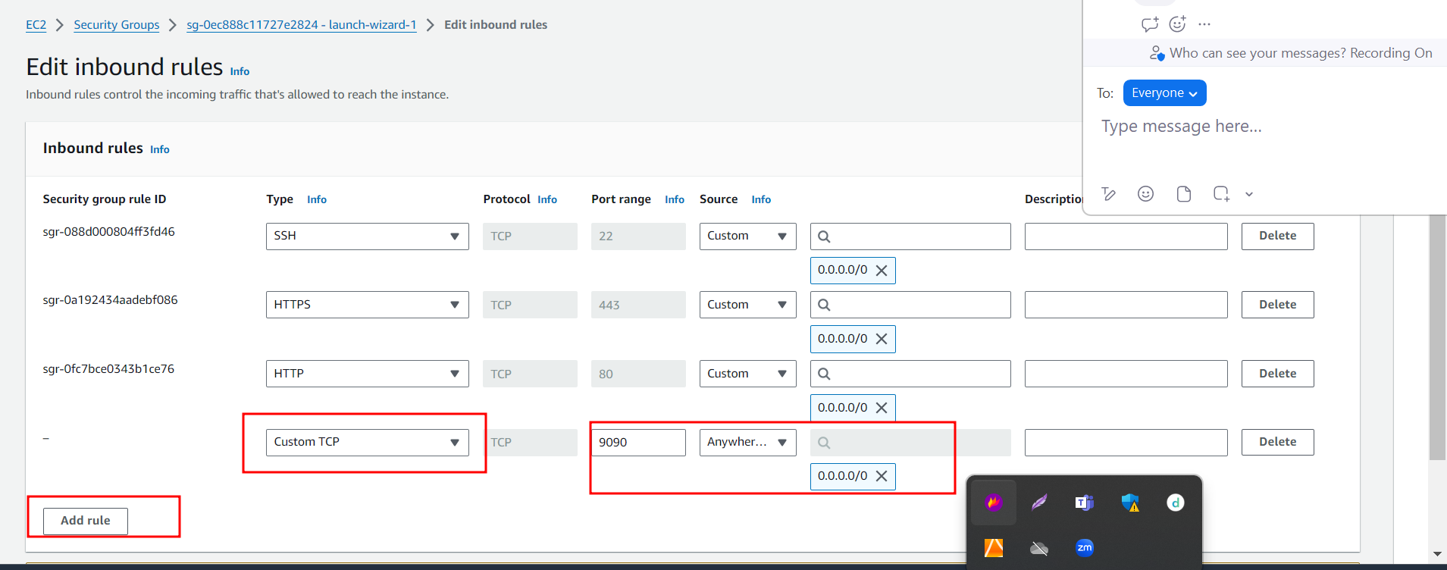

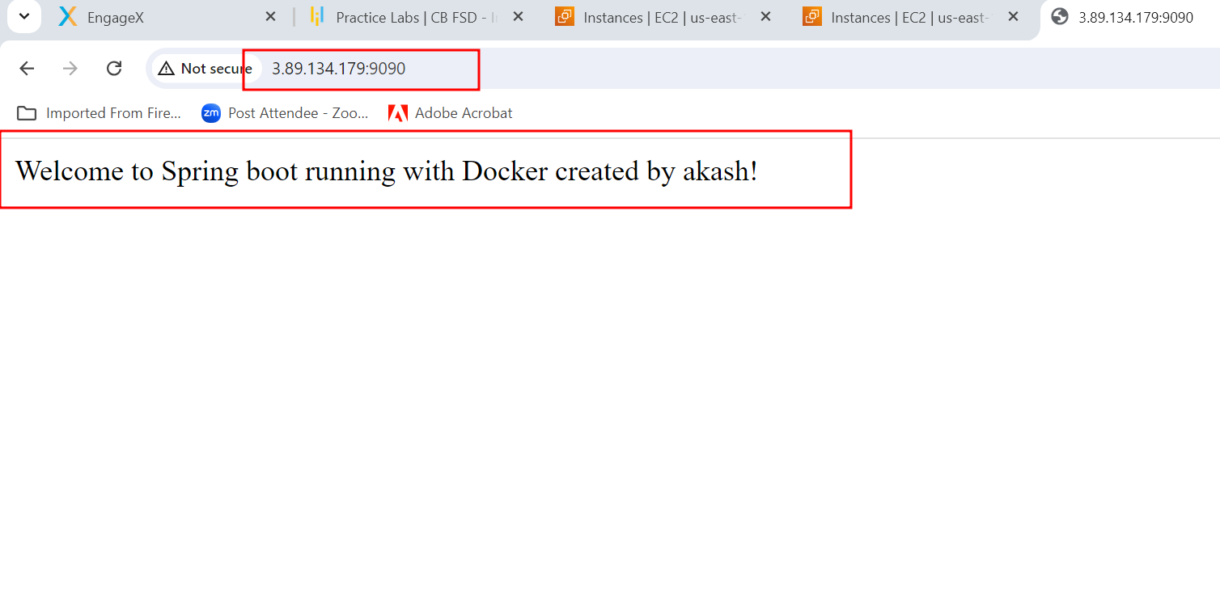

deploy angular application on EC2 instance with S3 bucket upload angular application or build file.

Or

Else we clone angular project in EC2 instance

Use any existing angular project or create new angular project using

Ng new angular-app

Do some work inside that project

Using ng build command build the project

If you are using existing project, please build the project using ng build command.

Another problem statement

<https://github.com/Kaleakash/angular_jenkin.git>

refer above repository to download sample angular project.

Now we need to install git in ec2 instance terminal.

sudo yum install git

git version

git clone <https://github.com/Kaleakash/angular_jenkin.git>

move inside a repository folder

cd angular_jenkin

using ls command verify all files and folder.

By default git ignore node_module folders,dist and target folder.

Now to run the angular project we need to install node js software

sudo yum install nodejs

node --version

npm --version

npm install (inside angular or react js project which read package.json file and download all required dependencies).

Now to build or run angular project we need ng command.

sudo npm install -g @angular/cli@16.0.1

ng version

ng build

it generates dist folder, inside dist folder it contains project_folder name and inside that build file present.

Move inside that folder

sudo npm install -g serve

serve -s (make sure you are inside build folder)

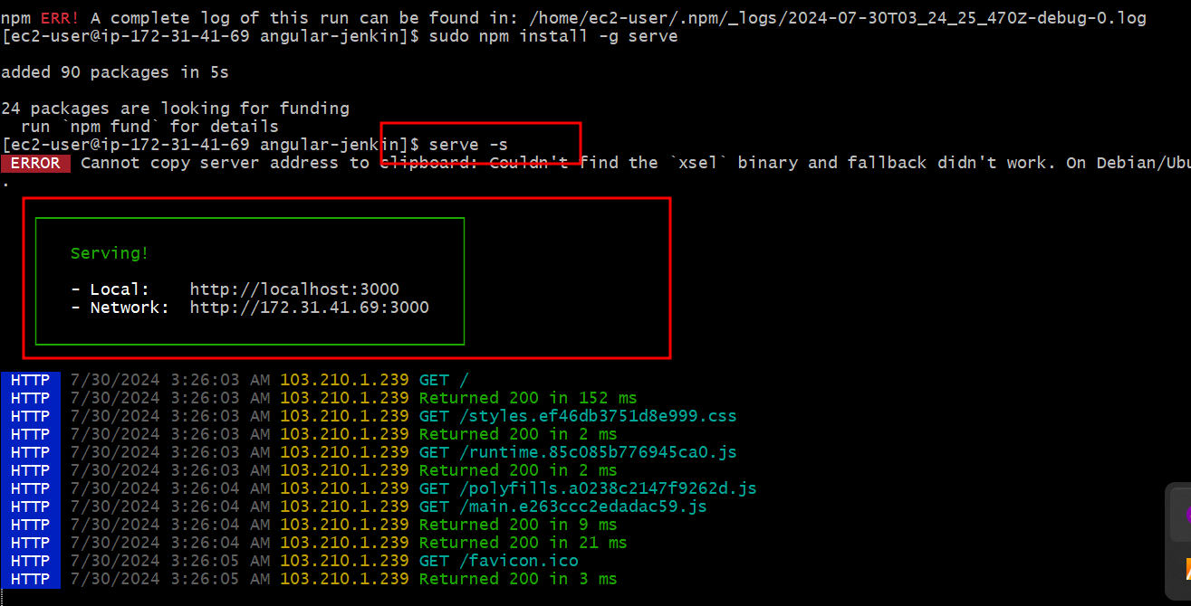

then our application run on port number 3000.

we can access this application using <http://publicIpAddress:3000>

But before access we need to open port number 3000 in security group with inbuild rule.